Optimization through Modelling: Revisiting the Popcorn Box Activity

Walter Whiteley

Ami Mamolo
During the last round of curriculum revisions, there was some discussion about exploring rate of change and optimization prior to students taking calculus. While there were concerns about effective ways to explore these big ideas without calculus, we offer evidence that it can be done. Over the last four years, a group has been developing investigatory activities that address optimization and rate of change in a geometric way. Our experiences with these activities not only confirm that there is a place for these investigations prior to calculus, but also convince us that it should be done to open up some “big ideas” that might otherwise be overshadowed as students grapple with the techniques of calculus.

The Investigation
This problem is adapted from the Popcorn Box activity that can be found in OAME’s Growing Up Mathematically materials for Grade 9, and in two versions for Grade 12:
An open-topped box (a popcorn box) is created from an 11”x11” piece of cardboard by cutting squares out of the four corners and folding up the sides. The student is asked to create the box of maximum volume from the piece of cardboard.

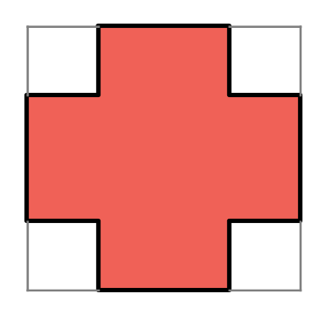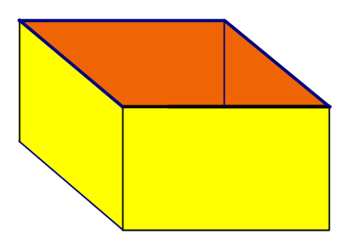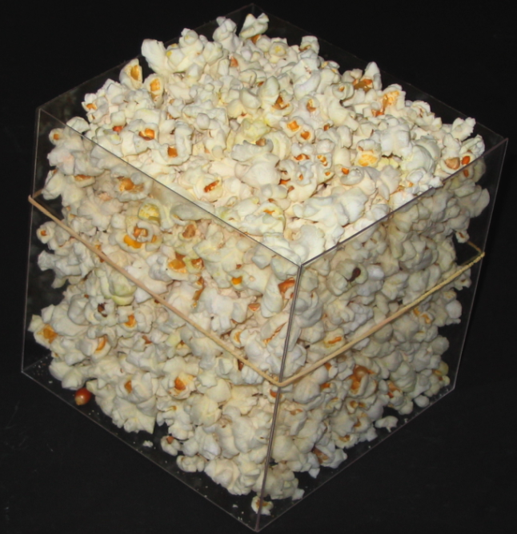
We have designed materials for a hands-on investigation of changes in volume, which also help foster key connections to important ideas of change and optimization. A detailed discussion of the materials and their implementation can be found in Whiteley and Mamolo (2010). In addition, worksheets and complementary activities in Geometer’s Sketchpad (Jaciew, 1989) are available on the wiki site on Optimizing with Geometric Reasoning (see References).
In brief, the investigation uses pairs of plastic boxes cut out from rigid plastic sheets that are held together with rubber bands, as in the above illustration. The pairs of boxes differ by 1 cm in the size of the cut. Volume comparisons and rate of change explorations are done through the use of foam “fills.” Pieces of foam are placed in the gaps along the sides between the boxes and on the top of the “inside box” to illustrate physically how the volumes are changing.
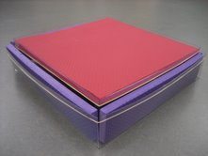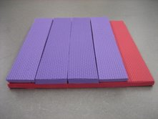
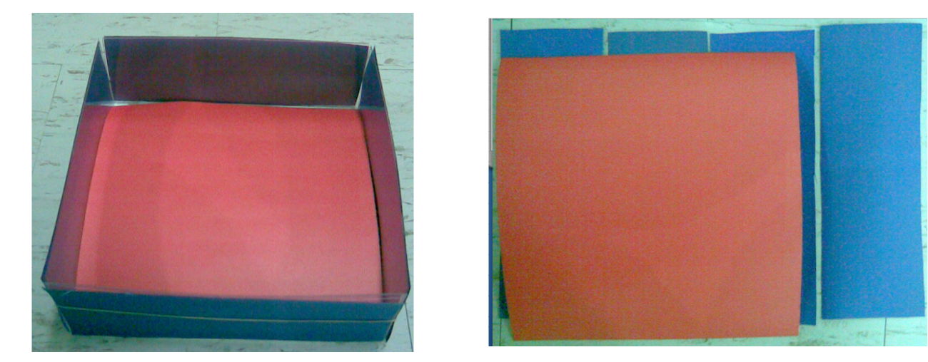
The materials afford a direct method to identify whether the volume gained in one box is larger or smaller than the volume lost in the other. In the diagram above, the volume gained (red foam) is larger than the volume lost (purple foam) for this pair of boxes. This exploration—as with those involving other pairs of boxes—offers the basis to conjecture what the box of maximum volume might be. However, there are limitations due to the size of the cuts made to the sheet of plastic and the corresponding thickness of the foam fills. These can be addressed by working with smaller changes in the square cuts—say, the thickness of cardboard—as illustrated below.

Big Ideas:
Important ideas that come up during this investigation include the following:
- The exploration promotes reasoning about changing volumes under constraints, focusing on the changes in volume (volume lost and volume gained).
- Changes in volume are connected to changes in surface areas (a big idea appearing in other situations that is illustrated when using thin materials such as cardboard).
- When the volume lost is smaller than the volume gained, we know that the outer box is smaller than the inner box, and therefore is not the maximum.
- The idea that when the change in surface area from one box to another is non-zero, we are not at the maximum, and thus, the optimum can occur only when the comparative change is zero.
- Working with physical materials invites using thinner materials and taking the limit physically to estimate the volumes lost and gained.
- To attain an optimum, the area of the four sides must match the area of the base, and, as illustrated in the figure, the squares that are cut out of the corners must have a length that is 1/6 of the length of the original side.

Extensions
There are a number of extensions and “What if?” problems available, as well as geometric techniques that can help investigate them. Here are some examples:
- What if the paper is not square? The reasoning about volume lost and volume gained carries over, as does the identification with volume changes and corresponding surface areas.
- What if we use a different shape (e.g., a triangle or a hexagon)? The reasoning connecting surface areas with changes in volume carries over completely. More surprisingly, the basic ratio of the cut also carries over (with one shift in focus), as illustrated in the sketch on the wiki site.
- The plane analog for areas in the plane, the “fence on the river,” has analogous reasoning, where change in area is identified with parts of the perimeter, and the optimum occurs when the perimeter where area is lost equals the perimeter where area is gained (see the GSP sketch on the wiki site). However, our experience is that the 3-D investigation makes more sense to the participants, and should be done first.
- If a box is constructed by tilting the sides out a little (as happens in the theatre), one can apply related qualitative reasoning comparing loss and gain to determine that the volume is increasing, without any trig calculations and without determining the exact optimum tilt.

Does it work?
The investigation has been used in settings ranging from math camp for students about to start Grade 9, to Grade 12 classes and classes for pre-service teachers and other mathematics majors, to professional development activities and graduate courses with teachers. It takes time, but we can confidently say that the activity engages students, prompts important questions and puzzles, and can, with enough time, bring participants to reasoning they can generalize and understanding that builds strong networks of connections for rate of change and optimization. For further information regarding this activity, including student reactions, strategies for implementation, and an in-depth discussion of the benefits and challenges of this approach, please refer to Whiteley and Mamolo (2010). As we continue to develop and refine this activity, its materials, and guiding instructional prompts, updates will be made on the wiki cited below.

References:

Jackiw, N. (1989). The geometer’s sketchpad. Berkeley: Key Curriculum Press, 1989.

Ontario Association for Mathematics Education. (2005). Growing up mathematically (GUM) [online version]. Retrieved from http://www.oame.on.ca/main/index1.php?lang=en&code=gum

Optimizing with Geometric Reasoning [wiki] http://wiki.math.yorku.ca/index.php/Optimizing_with_Geometric_Reasoning

Whiteley, W., & Mamolo, A. (to appear). Optimizing in Geometric Contexts: A New Approach to The Popcorn Box Activity. The Mathematics Teacher.

